AMIT KUMAR
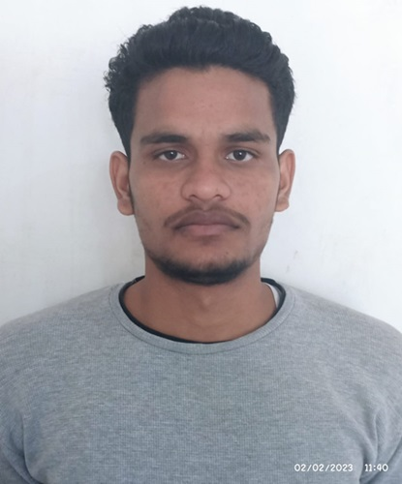

Address: Nagla heera, Iglas, Aligarh.
+918445662642, eng.amit.thenua@gmail.com
GitHub: [https://github.com/engamitthenua-byte/MY-projects.git]
LinkedIn:[www.linkedin.com/in/amit-kumar-28063b342]

Career objective

Aspiring Software Developer with a strong foundation in programming, web technologies, and database management. Seeking an opportunity to apply my technical skills, learn new technologies, and contribute to innovative projects within a dynamic organization.

Education
BCA, computer science and engineering 2023-26
Mangalayatan University, Aligarh, Uttar Pradesh, India

Intermediate, Science, Ist division with 67.20% 2022
BLS International School, Hathras, Uttar Pradesh, India
High School, Ist division with 83.40% 2020
BLS International School, Hathras, Uttar Pradesh, India

Accomplishments/ Certification

- Successfully completed the MERN Stack Development Internship at IIT Ropar from December 2025 to January 2026.
- Successfully Completed One Month internship with Carnival Media during the period of November 2024.
- Successfully completed the Web Development Internship at Proxenix from July 2025 to September 2025.
- Successfully completed “Programming with Python” course with the collaboration of Skill India and NSDC certification. The certificate award with Grade B.
- Successfully completed 12 weeks of Core JAVA programming course from NPTEL (National Program on Technology Enhanced Learning).
Projects

- Phishing Detection and Simulation System(Node.js, Express.js, HTML, CSS, JavaScript).
- Real-Time Chat Application (Node.js, Express.js, Socket.IO, HTML, CSS, JavaScript).
- Customer Feedback Collection System (Python, Flask, SQLite, HTML, CSS, JavaScript).
- CRUD Record-Keeping Application (Python, Flask, SQLite, HTML, CSS).

Technical Skills
• Programming Languages: Python, JAVA, JavaScript, HTML, CSS.
• Frameworks & Tools: Flask, Node.js, Express.js, Socket.IO, Git, PyInstaller.
• Database: MongoDB, SQLite, MYSQL.
• Concepts: Web Development, CRUD Operations, Real-Time Communication, Responsive
Design.
• Other Skills: MS Word, Excel, Team Collaboration, Fast Learner, Positive Attitude.

Additional Information.

- Strong interest in software and full-stack web development.
- Basic Knowledge of Computer Software and hardware’s.
- Knowledge of MS word, MS Excel etc.

